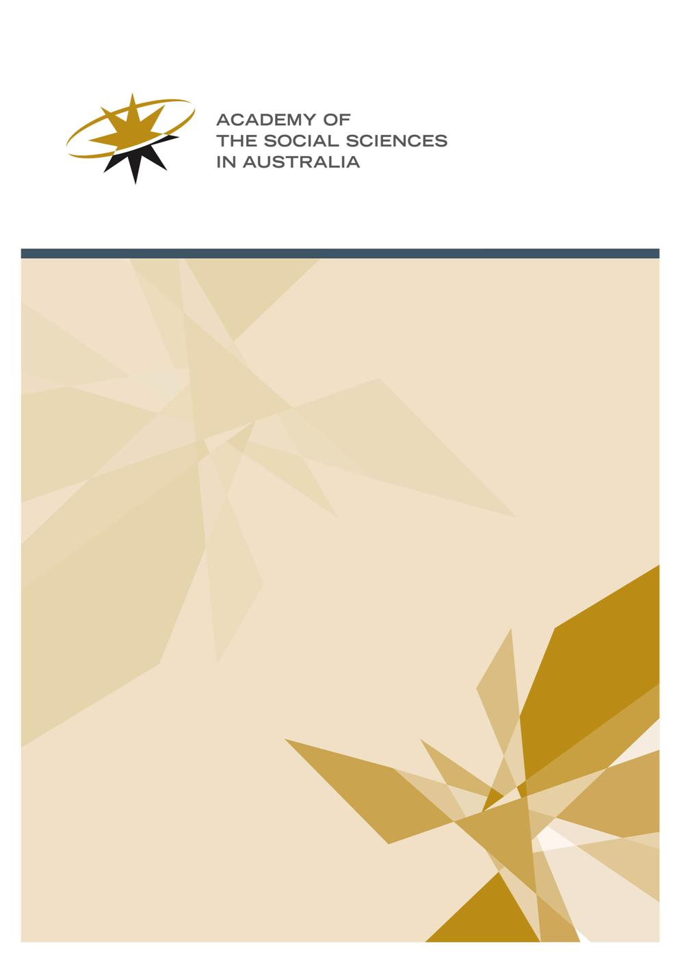

ASSA Workshop Program 2020-21

Grant Application Guidelines
- The Workshop Program

The Workshop Program is ASSA’s main outward-facing method for promoting social science research. Often the ordinary course of things does not bring those at the forefront of research in a particular field into face to face contact. ASSA Workshops aim to address this, providing a forum for sharing ideas and discussing arguments. Workshops seek to include a diversity of perspectives from across various disciplines and schools of thought within the social sciences, and there is emphasis on active researchers.

  - Purpose

The purpose of the Workshop Program is to advance knowledge through sustained discussion. Its outcomes are published in order that it might influence academic debate as well as policy direction. ASSA expects:

- All papers presented at Workshops be readily available in the public domain, with appropriate attribution of opinion by participants.
- Where applicable some emphasis on policy and the development of policy statements. Policy statements act as signposts rather than detailed prescriptions—for instance, offering advice grounded in social science research which suggests appropriate responses to social problems, or offering advice which advances the debate on issues requiring policy intervention or consideration by government.
- All workshops, even those with a clear intention to produce a policy outcome, be rooted in the social sciences.

  - Format

A workshop is a series of presentations and discussions among researchers on different aspects of one topic. Workshops consist of a series of structured presentation of ideas, followed by questions and discussion. They standardly run for two days, including an informal dinner after the first night, at which further discussion can continue in a freeform way.

A range of disciplines and institutions should be represented, and the topics and participants should reflect this diversity. ASSA expects participants to include both established researchers and leaders in their areas of expertise, and early career researchers who are challenging or adding to debate (there is a requirement that at least two early career researchers based in Australia attend).

N.B.: For the purpose of the Workshop Program, early career researchers have been awarded a PhD or equivalent research doctorate, or commenced working as a researcher in a tertiary institution, within the last five years (a longer time period is permitted if there have been significant career interruptions).

Participation is not limited to academics—where appropriate, experts from government, community, and the private sector should be invited. This is particularly relevant if there are practical or policy components to a workshop proposal.

In order to allow for meaningful exchange of ideas and extensive debate, numbers are limited to 20 participants. Workshops are not public forums. The Academy expects all participants to attend the entire workshop program.

  - Parameters

Funding is for workshops to be held in the 2020-21 financial year.

Workshops will be funded to a maximum of $9,000. This sum includes provision for $1,500 towards the cost of a digested analysis. All grant recipients are required to provide a digested analysis.

The number of workshops funded and the amount allocated depend on the Academy's overall budget, which is subject to change.

Workshop applications will be assessed on their themes, quality of participants, range of specialisation, experience of contributors, strength of the proposal and program, and significance of expected outcomes. They should have a clear conceptual framework, a statement of objectives, a program of proposed topics and speakers for each session, and a meaningful proportion of participants confirmed as attending. The program should clearly reflect the workshop objectives.

Applicants should consider the Strategic Statement of the Academy in addressing the likely benefits of the proposed workshop. This can be found at: http://www.assa.edu.au/assa-strategic-statement/. Applicants may wish to highlight the relevance of their application to facilitating excellence in social science research, developing early and mid-career social science researchers, and enhancing social science research capacity. Multi-disciplinary programs, engagement with business, industry, non-governmental organisations, and the community, and dissemination of the Academy’s work nationally and internationally may also be considered. Applications need not address all listed strategies, but should highlight those of relevance.

  - Convenors

Workshops may have up to three convenors. At least one must be an ASSA fellow. Exception to this rule will only be made if applicants can clearly demonstrate there is no appropriate fellow available to convene the workshop, hence no alternative but to nominate convenors who are not Fellows. A list of the Academy’s fellows can be found at:

http://www.assa.edu.au/fellowship/fellows

The responsibilities of the convenors include:

- Ensuring the smooth planning and operation of the workshop.
- Working with the ASSA on development of a media release for the workshop.
- Ensuring the ASSA’s name and logo is printed on all invitations, programs, publicity for the workshop, as well as resulting publications and outputs such as websites and online articles. ASSA must be acknowledged as a sponsor of the workshop.
- Providing two reports within two months of the workshop:

  - A 1,500-3,000 word digested analysis report. This report is not a description of the events at the workshop, but an overview of the issue the workshop treated and the conclusions which came out of the discussion. They should contain—as a guide—the following:

- A primer outlining the history of the issue and its social significance
- An explanation of the different points of view on the issue—what is the current state of play in the debates?
- An outline of the interested parties and the potential policy implications
- An idea of how the issue might develop in the next 5-10 years
- An indication of what further research needs to be undertaken

Digested analyses should be written for a non-specialist audience and be ready for public consumption. ASSA will publish these on its website, and will distribute them through its social media channels and its mailing list.

Suitable models for the digested analysis could range from the style used to explain academic research in a contribution to The Conversation, to the style used in a background Policy Brief. The following two reports are exemplary of what digested analyses should strive to emulate:

https://aeon.co/ideas/opportunity-costs-can-carbon-taxing-become-a-positive-sum-game
https://theconversation.com/ultra-low-wage-growth-isnt-accidental-it-is-the-intended-outcome-of-government-policies-113357?utm_source=twitter&utm_medium=twitterbutton

  - A second report is required for administrative purposes. This comprises a copy of the final program (including dates, venues, and convenors), a list of all participants, and a short summary of plans for publication and dissemination of results. Convenors may include in this report any observations about the value of the contribution made by the Workshop Program. It may also include suggestions for changes or improvements to the program, in order to assist its development.
  - Note: for proposals with a policy focus, your letter of offer may request you provide a short policy statement. This should outline the main policy implications identified during the workshop. It may be published on ASSA’s website. It may also be provided to policy makers as agreed in consultation between the convenors and the Workshop Committee.

- Submitting a budget acquittal within two months of the date the workshop was held.

  - Outcomes

ASSA expects dissemination of workshop outcomes through publication by a recognised publishing house or refereed academic journal.

In addition, suitable outcomes might include publication in a professional journal; publication on a university, institution, or academy website, or; circulation of a media article (for instance, newspaper, radio, or television).

  - Application deadline

Application forms should be submitted by Friday, 4 October 2019

  - Application Submission

Application forms should be submitted via email to:
Dylan Clements
Programs Manager
Academy of the Social Sciences in Australia
Email: dylan.clements@assa.edu.au
Phone: (+61) 2 6249 1788

Important information

- Funding is for workshops to be held in the 2020-21 financial year.
- Workshop applications will be assessed on their themes, quality and range of participants, strength of the proposal and program, and significance of expected outcomes.
- Applications should have a clear conceptual framework, a statement of objectives, a program of proposed topics and speakers for each session, and a meaningful proportion of participants confirmed as attending.
- The program should clearly reflect the workshop objectives.
- Workshops will be funded to a maximum of $9,000.
- The deadline for applications is Friday 4 October 2019

