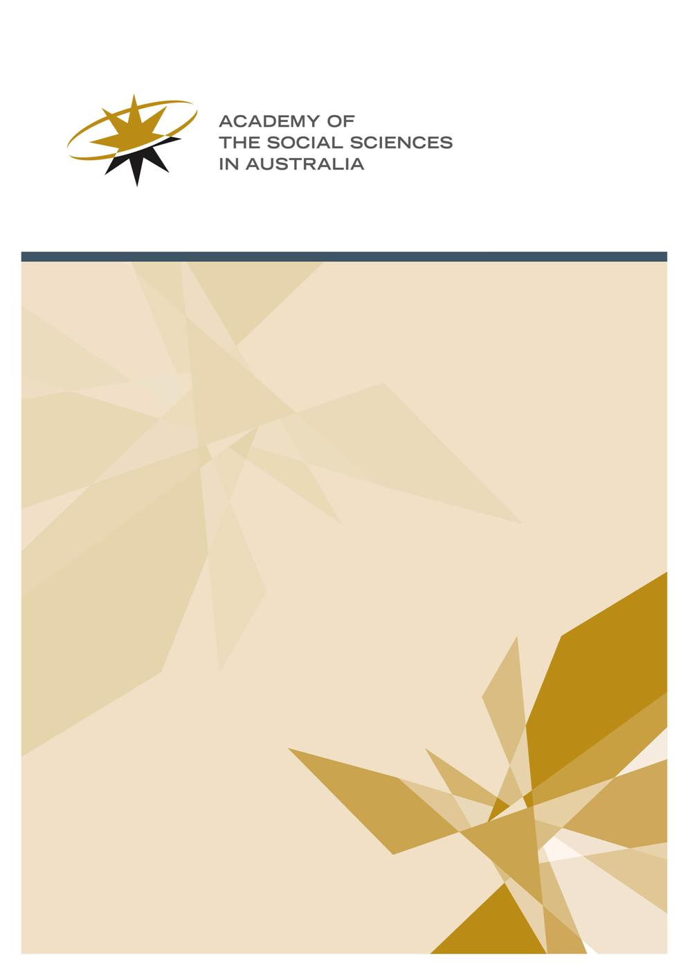

ASSA Workshop Program 2019-20

Grant Application Guidelines
- The Workshop Program
The Workshop Program is a principal component in the Academy’s promotion of research in the social sciences. Academy Workshops are gatherings of those working at the forefront of social science research. They are held so these people may share ideas and discuss arguments with one another, as often the ordinary course of things will not bring these people into face to face contact. In workshops, a diversity of perspectives is presented from across various disciplines within the social sciences, and there is emphasis on active researchers in lists of invited participants.
  - Purpose
The purpose of the Workshop Program is to advance knowledge through sustained discussion. It also aims to promote its uptake in debate, and its application in policy, by the publication and communication of workshop outcomes. The ideas and research discussed at workshops are exposed to scrutiny and rigorously debated by scholars within the social sciences. The Academy expects:
- All papers presented at workshops are readily available in the public domain, with appropriate attribution of opinion by participants.
- Encouragement is given to participants to develop policy statements. Policy statements act as signposts rather than detailed prescriptions—for instance, offering advice grounded in social science research which suggests appropriate responses to social problems, or offering advice which advances the debate on issues requiring policy intervention or consideration by government. Policy statements can also raise awareness of social science research and highlight its relevance for policy development and implementation.
- All workshops, even those with a clear intention to produce a policy outcome, will be rooted in the social sciences.
  - Format
A workshop is a series of presentations and discussions among researchers on a single topic. Standardly, they run for two days. Workshops consist of a structured presentation of ideas, followed by questions and discussion. They also comprise an informal dinner after the first night, at which further exchange and discussion can continue in a freeform way. A range of disciplines and institutions should be represented, and the topics and participants should reflect this diversity. The Academy expects participants will include:
- Established researchers and leaders in their areas of expertise.
- Early Career Researchers who are challenging or adding to debate. There must be at least two early career researchers who are based in Australia.
NB: For the purpose of the Workshop Program, Early Career Researchers have been awarded a PhD or equivalent research doctorate, or commenced working as a researcher in a tertiary institution, within the last five years (a longer time period is permitted if there have been significant career interruptions).
Participation is not limited to academics—where appropriate, experts from government, community, and the private sector should be invited. This is particularly relevant if there are practical or policy components to a workshop proposal. In order to allow for meaningful exchange of ideas and extensive debate, numbers are limited to 20 participants. Workshops are not public forums. The Academy expects all participants to attend the entire workshop program.
  - Parameters
Funding is for workshops to be held in the 2019-20 financial year.
Workshops will be funded to a maximum of $9,000. This sum includes provision for $1,500 towards the cost of a digested analysis. All grant recipients are required to provide a digested analysis.
The number of workshops funded and the amount allocated depend on the Academy's overall budget, which is subject to change.
Workshop applications will be assessed on their themes, quality of participants, range of specialisation, experience of contributors, strength of the proposal and program, and significance of expected outcomes. They should have a clear conceptual framework, a statement of objectives, a program of proposed topics and speakers for each session, and a meaningful proportion of participants confirmed as attending. The program should clearly reflect the workshop objectives.
Applicants should consider the Strategic Statement of the Academy in addressing the likely benefits of the proposed workshop. This can be found at: http://www.assa.edu.au/assa-strategic-statement/. Applicants may wish to highlight the relevance of their application to facilitating excellence in social science research, developing early and mid-career social science researchers, and enhancing social science research capacity. Multi-disciplinary programs, engagement with business, industry, non-governmental organisations, and the community, and dissemination of the Academy’s work nationally and internationally may also be considered. Applications need not address all listed strategies, but should highlight those of relevance.
  - Convenors
Workshops may have one or several convenors. At least one of the convenors must be a Fellow of the Academy. Exception to this rule will be made if and only if the applicants can clearly demonstrate there is no appropriate Fellow available to convene the workshop, hence no alternative but to nominate convenors who are not Fellows. A list of the Academy’s fellows can be found at: http://www.assa.edu.au/fellowship/fellows.
The responsibilities of the convenors include:
- Ensure the smooth planning and operation of the workshop.
- Work with the Academy on development of a media release for the workshop.
- Ensure the Academy’s name and logo (available on request from the Programs Manager) is printed on all invitations, programs, publicity for the workshop, as well as resulting publications, outputs such as websites and online articles. The Academy should be acknowledged as a sponsor of the workshop.
- Provide two reports within two months of the workshop:
  - The main report is a digested analysis. This is an account and analysis of the content of the discussions. It should pick out the most interesting and important issues, cover the main conclusions of the workshop, and determine appropriate next steps for the inquiry. It should identify the author/s, and it should be suitable for publication on the Academy’s website. It should also be suitable for distribution to media, policy makers, and opinion leaders. All in all, digested analyses should be written predominantly for a non-specialist, public audience. Depending on the subject matter of the workshop, suitable models for the digested analysis could range from the style used to explain academic research in a contribution to The Conversation, to the style used in a background Policy Brief. There are currently some exemplary analyses on the Academy’s website (for example: http://www.assa.edu.au/event/going-beyond-the-crisis-response-building-trust-and-maintaining-legitimacy-for-all-stakeholders-in-environmental-flows-and-water-governance/)
  - A second report is required for administrative purposes. This report comprises a copy of the final program (including dates, venues, and convenors), a list of all participants, and a summary of plans for publication and dissemination of results. Convenors may include in this report any observations about the value of the contribution made by the Workshop Program. It may also include suggestions for changes or improvements to the program, in order to assist its development.
- For proposals with a policy focus, your letter of offer may request you provide a short policy statement. This should outline the main policy implications identified during the workshop. It may be published on the Academy’s website. It may also be provided to policy makers as agreed in consultation between the convenors and the Workshop Committee.
- Submit a budget acquittal within two months of the date the workshop was held.
  - Outcomes
The Academy expects dissemination of workshop outcomes through publication by a recognised publishing house or refereed academic journal.
In addition, suitable outcomes might include:
- Publication in a professional journal
- Publication on a university, institution, or academy website
- Circulation of a media article (for instance, newspaper, radio, or television)
For reference, examples of past workshops funded by the Academy are available at: http://www.assa.edu.au/events/workshops/.
  - Application deadline
Application forms should be submitted by Friday, 5 October 2018
  - Application Submission
Application forms should be submitted via email to:
Dylan Clements
Programs Manager
Academy of the Social Sciences in Australia
Email: dylan.clements@assa.edu.au
Phone: (+61) 2 6249 1788

Important information
- Funding is for workshops to be held in the 2019-20 financial year.
- Workshop applications will be assessed on their themes, quality and range of participants, strength of the proposal and program, and significance of expected outcomes.
- Applications should have a clear conceptual framework, a statement of objectives, a program of proposed topics and speakers for each session, and a meaningful proportion of participants confirmed as attending.
- The program should clearly reflect the workshop objectives.
- Workshops will be funded to a maximum of $9,000.
- The deadline for applications is Friday 5 October 2018.

